* How to retrieve Amazon machine image (AMI) with the help of snapshot, if accidentally terminated

1. Open AWS service and select EC2 launch instance choose window server R2 base 2012 .

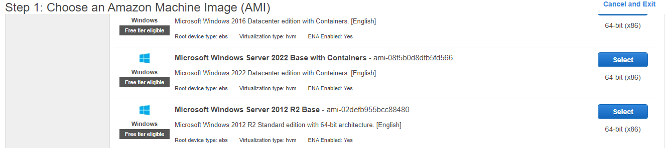

1. Select instance type t2 micro this is only eligible for free tier aws account .

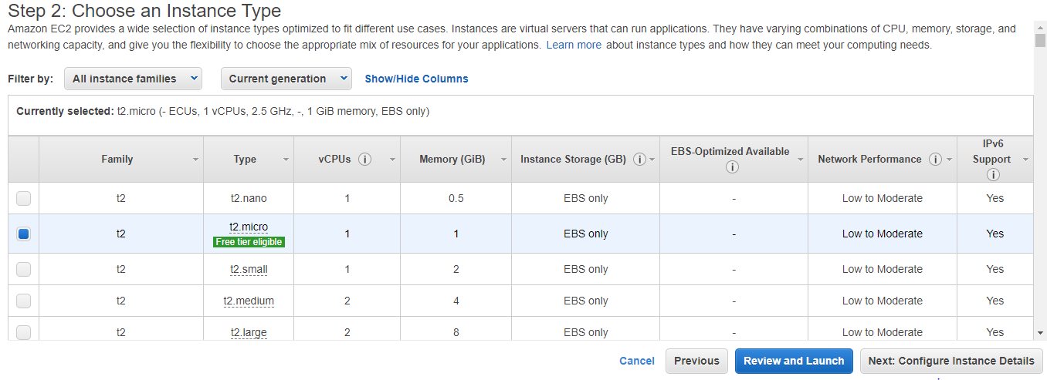

1. Next configure instance detail .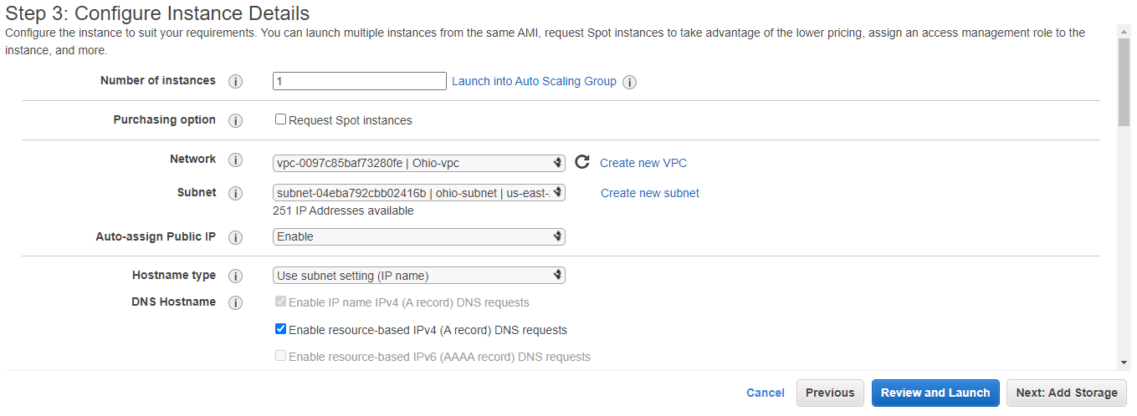

.

There is number of instance, i selected 1 and network type i chose my own created vpc in Ohio region it take itself subnet because while creating vpc i selected and availability zone too.

Auto assign public IP have to enable then we get public IP. when we select own created vpc we should have to enable auto assign public IP it don’t choose default and to do this all thing we go for next configure add storage.

5. Next configure add storage .

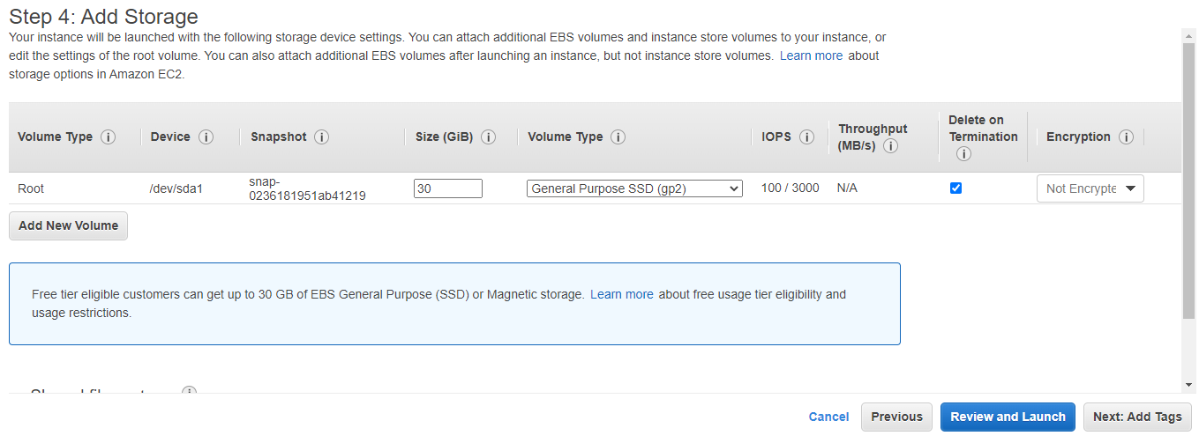

There is root volume provide upto 30gb for fee tier account but we can extend the size of root volume but we have to pay for that.

there is four type of root volume

1. General purpose ssd (gp2)
2. General purpose ssd (gp3)
3. Provisioned IOPS (io1)
4. Provisioned IOPS (io2)

I selected 1 general purpose ssd gp2 for normal use, it provide IOPS minimum

100 and maximum 3000 iops that ok for normal use if we want more IOPS then go

provisioned iops ssd type.

We can add more volume from here EBS type volume .

6. Next step to tag name .

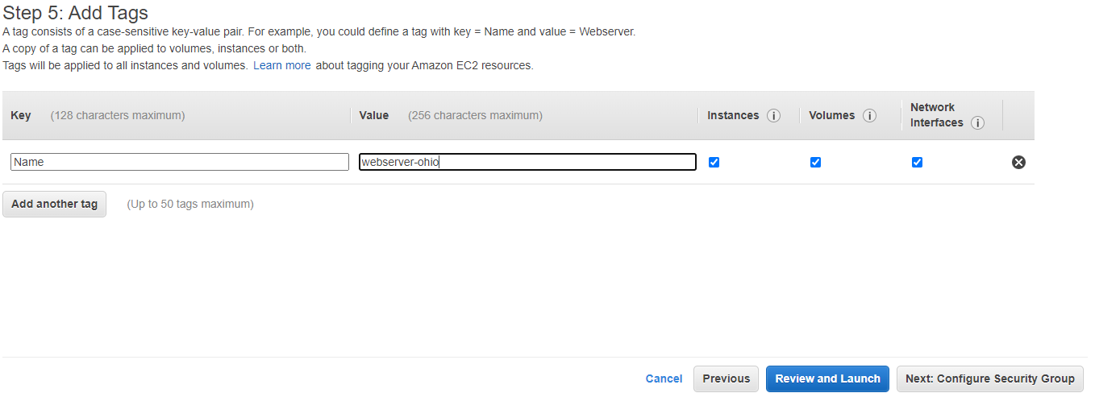

7. Next step to configure security group .

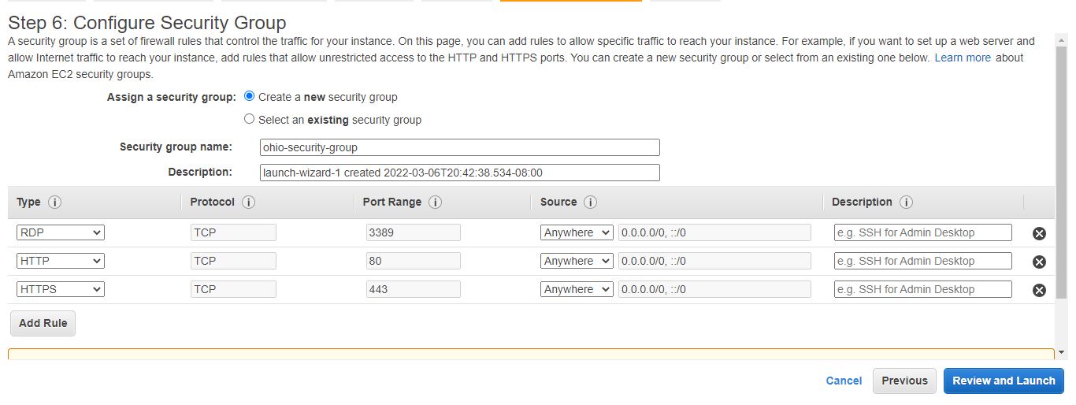

Configuration of security group we can create new security group but can choose existing group too.

We choose RDP type security which has port rang 3389, HTTP port rang 80 and HTTPS port rang 443 and then click review & launch.

8. Next step to review and launch .

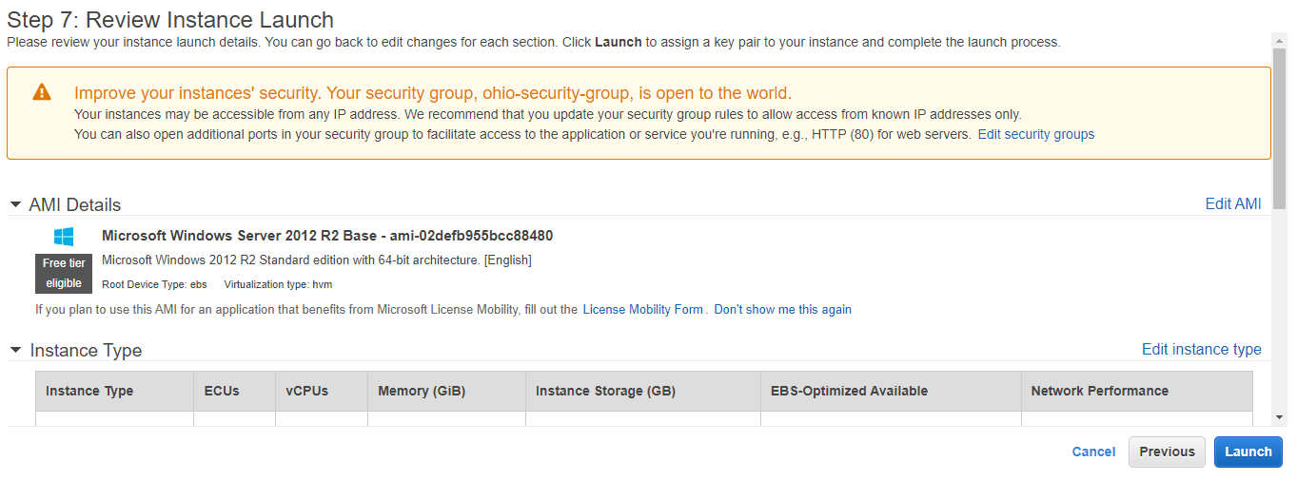

9. In this step we create a keypair name .

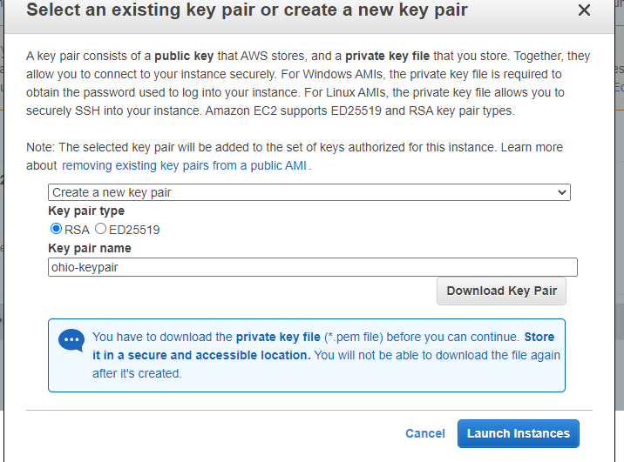

There is have to make keypair for the security further use to get password when we take RDP.

10. In this step our instance successfully launch then we have wait a few minutes until it’s status show 2/2

After launch the instance we can take RDP .

11. This step to take RDP and we connect to the web server window server R2 base .

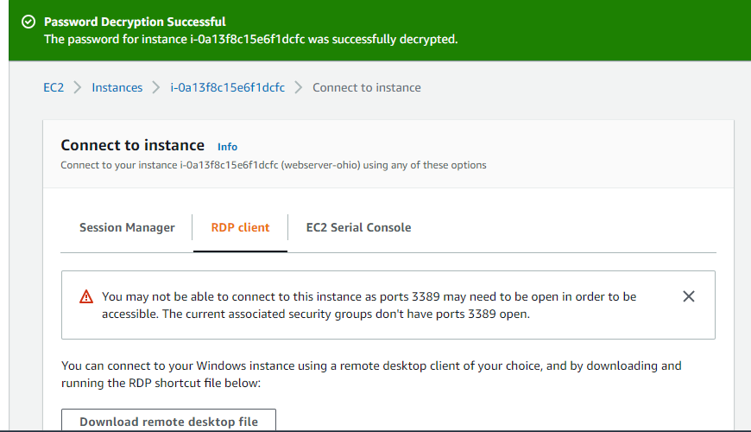

In this step we gor for take RDP client and download RDP file and get password that keypair which we created and dycrypt the password and then open RDP.

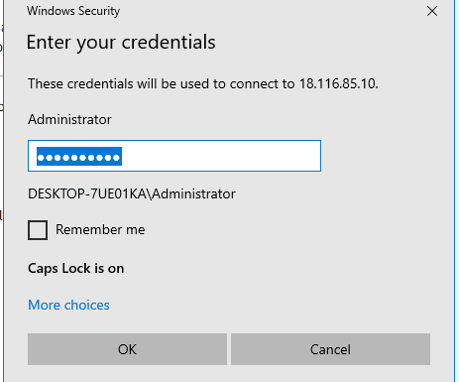

Now i is connected with the server window server 2012 R2 base.

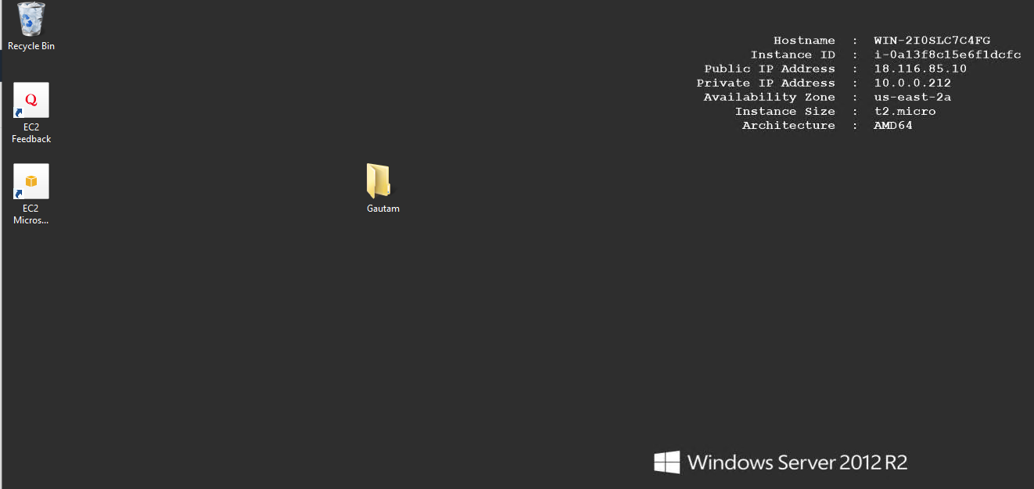

12. In this step we are going to take snapshot of the root volume of this server but before we go for snapshot we have to stop the instance we can take here snapshot without stop the instance because there is no data transfer but real scenario we must have to stop the instance before take snapshot .

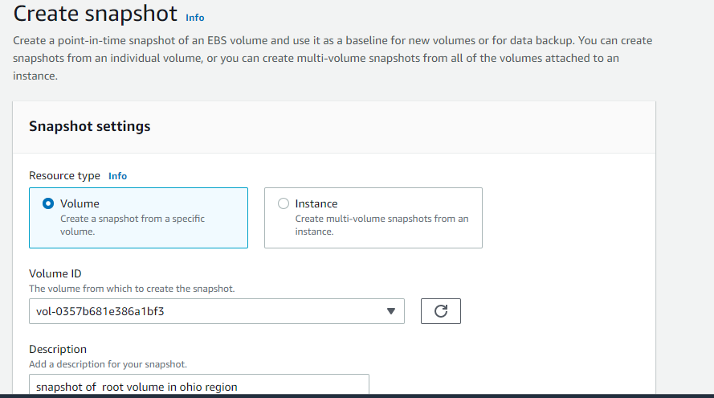

Here we go for take snapshot resource type of volume of the instance in Ohio region..

Now we took snapshot successfully done. It is availability zone specific we can use it one availability zone to another availability zone in same region.

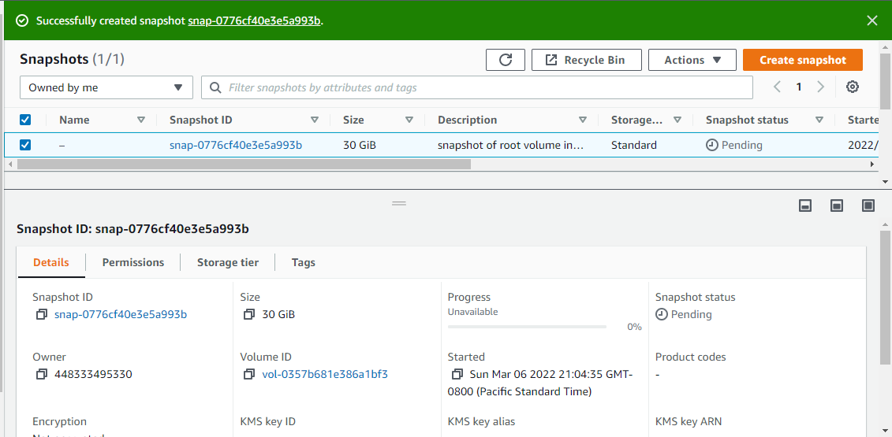

13. In tis step we go for make AMI with the help of snapshot .

Click action and then choose make AMI from snapshot .

1. Tag the ami name
2. Fill description
3. Click create 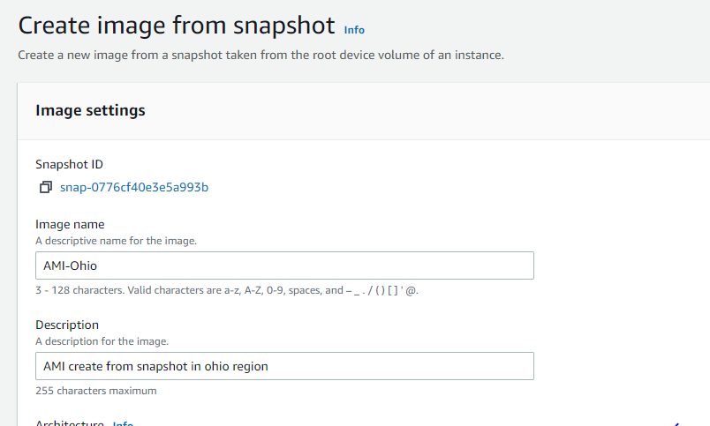

Here it display detail about AMI. there is only one volume we has chosen that was root volume.

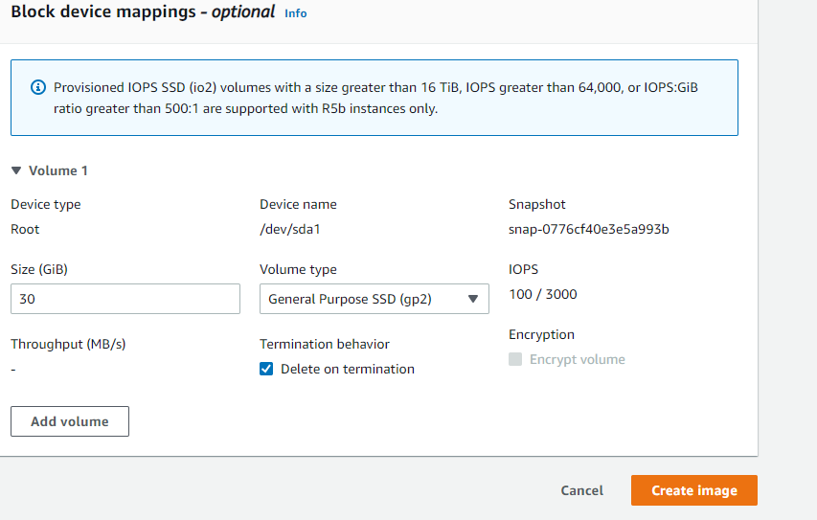

Now we can see,AMI successfully done . it is region specific, we can use to make volume or launch instance one region to another region.

